INTERNSHIP PROJECT REPORT

SUBMITTED IN PARTIAL FULFILLMENT OF GRADUATE PROGRAM

(Bachelor Of Technology)

(Electronics and Communication Engineering)



YMCA University of Science and Technology

Faridabad

Submitted by

Sidharth Mehta

ECE-2491-2k14

# Training Completion Certificate

This is to certify that the project work titled “Bluetooth Module” submitted to YMCA University of Science and Technology, Faridabad in partial fulfilment for the award of the Degree of Bachelor of Technology in Electronics and Communication Engineering is the work done by Sidharth Mehta under our supervision and guidance.

________________________________

(Branch Manager)

Mr. Bhim Chand

(External Examiner)

# Candidate Declaration

I, the undersigned, Sidharth Mehta, student of B.Tech (7th sem) in Electronics and Communication Engineering hereby declare that the project work presented in this report is my own work and carried out under the supervision of Mr. Bhim Chand, Branch Manager, Emtech Foundation.

Date:

Signature: _____________

Place:

(Sidharth Mehta)

# Acknowledgement

I’m greatly indebted to **Mr. Naveen Kumar (CEO, Emtech Foundation) for** coordinating this training and giving me an invaluable opportunity to work in a competitive yet amicable atmosphere.

My grateful thanks to **Mr. Bhim Chand (Branch Manager, Emtech Foundation)** who in spite of being extraordinarily busy with his duties took time to hear, guide and keep me on the correct path. I do not know where I would have been without him. A humble ‘Thank You’ Sir.

I am thankful to **Mr. Dinesh Kumar (R&D** **Head, Emtech Foundation)** who monitored my progress and guided me to complete my project and provides me with such an excellent opportunity.

Last but not the least there were so many who shared valuable information that helped in the successful completion of this project.

**Sidharth Mehta**

Contents

Training Completion Certificate i

Candidate Declaration ii

Acknowledgement iii

1. Company Profile 2

2. Abstract 4

3. Competition 6

3.1 SMBT-1T02 6

3.2 HC-05 6

4. Tools 8

4.1 IAR Embedded Workbench 8

4.1.1 Creating a Simple Blinky Project 9

4.2 Toshiba Wireless starter kit 17

4.3 CMSIS DAP 18

4.3.1 Pinout 18

4.4 STM Nucleo L053R8 20

4.5 PuTTY 22

4.5.1 Setting up a serial terminal 22

4.6 STM32 CubeMX 25

4.6.1 Demo of Project Making and Initialization Process: 26

4.7 µVISION ide 31

4.7.1 µVision Project Manager and Run-Time Environment 31

4.7.2 µVision Editor 32

5. Bluetooth 34

5.1 Serial Port Profile (SPP) 35

5.2 Bluetooth Protocols 35

5.3 Host controller interface (HCI) 35

6. Toshiba TC35661 38

6.1 Key Benefits 38

6.2 Features 38

6.3 TC35661SBG-503 Bluetooth® IC 39

6.3 UART Interface: 41

7. Modules Implemented 43

7.1 Porting code from TMPM 369 to Nucleo board 43

7.2 Writing AT commands for module 43

7.3 Future goals of project 43

8. Applications 45

Example 1: Light Switch Controller 45

Example 2: Remote Data Logger 45

Example 3: Wearables 45

9. References 47

1. Company Profile

# Company Profile

**Embedded Technology Foundation** is the most trusted electronics skill development and job placement organisation in India. It is doing training programs in partnership with [**Electronics Sector Skills Council of India (ESSCI)**](http://www.essc-india.org/) and [**Microchip Technology Inc, USA**](http://www.microchip.com/). Most of its training programs comes under govt. financing scheme launched to support Skill India Mission like “PMKVY (Pradhan Mantri Kaushal Vikas Yojna)” and “Scheme for Skill Development in ESDM for Digital India”. It had trained more than 10,000 Electrical and Electronics engineers since 2006 and most of them have successful job placement in core electronics industries in India and overseas. To meet growing need of electronics industries, it is associated with NXP Semiconductor, Renesas, ST Microelectronics, Toshiba Semiconductor, Texas Instruments, Toradex Systems for training on their microcontrollers/microprocessors.



It is one of the supporting/training partner of NSDC (National Skill Development Corporation) comes under Ministry of Skill Development and Entrepreneurship (MSDE) in Electronics Skill for WorldSkillsSaoPaulo2015, IndiaSkills2016 and WorldSkillsAbuDhabi2017.

Under the dynamic leadership of its Founder and CEO **Sh. Naveen Kumar**, it has been honoured by National Educational Excellence Award 2016 for Best Embedded Systems Training Institute in North India.

# 

1. Abstract

# Abstract

These days it feels like everything is wireless, and Bluetooth is a big part of that wireless revolution. You’ll find Bluetooth embedded into a great variety of consumer products, like headsets, video game controllers, speakers etc.

In the world of embedded electronics hackery, Bluetooth serves as an excellent protocol for wirelessly transmitting relatively small amounts of data over a short range (<100m). It’s perfectly suited as a wireless replacement for serial communication interfaces.

But the Bluetooth IC manufactured by the companies are not easy to use and mostly rely on software for their working. Therefore, to reduce this burden of writing the firmware for the Bluetooth IC, Bluetooth modules are made by individual vendors.

These vendors write the firmware for these Bluetooth IC for specific as well as for general purposes.

In consumer electronics and in the field of hobbyists, these Bluetooth modules are used. These modules help in development and ease out the work of application developers.

The Aim of project is to write the firmware for interfacing such a Bluetooth IC, TC35661, manufactured by Toshiba with a controller. This is a BLE (Bluetooth Low Energy) device, which supports GATT Profile as well as Bluetooth classic.

In the end, the device should be able to scan, pair and should be able to share data back and forth with other Bluetooth devices like an Android Phone or a Laptop.

1. Competition

# Competition

## 3.1 SMBT-1T02

SMBT-1T02 is a single board solution with Bluetooth classic and Low energy dual mode 4.0. SMBT-1T provides Bluetooth SPP (Serial Port Profile) function, GATT (Generic Attribute Profile) function, and LE (Low Energy) function specified in Bluetooth™ Specifications.

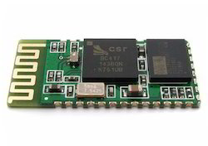

Figure 3.1

## 3.2 HC-05

**HC‐05 module** is an easy to use **Bluetooth SPP (Serial Port Protocol) module**, designed for transparent wireless serial connection setup. The HC-05 Bluetooth Module can be used in a Master or Slave configuration, making it a great solution for wireless communication. This serial port Bluetooth module is fully qualified **Bluetooth V2.0+EDR (Enhanced Data Rate)** 3Mbps Modulation with complete 2.4GHz radio transceiver and baseband. It uses **CSR Bluecore 04**‐External single chip Bluetooth system with CMOS technology and with AFH (Adaptive Frequency Hopping Feature).

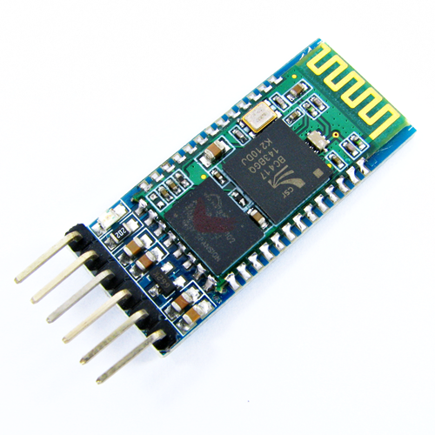

Figure 3.2

1. **Tools**

# 

# Tools

## 4.1 IAR Embedded Workbench

IAR Systems is a Swedish computer software company that offers development tools for embedded systems. IAR Systems was founded in 1983. “IAR” is an abbreviation of Ingenjorsfirman Anders Rundgren, which means Anders Rundgren Engineering Company.

IAR Systems develops C and C++ compilers, debuggers, and other tools for developing and debugging firmware for 8-, 16-, and 32-bit processors. The company started out in the 8-bit market, but moved into the expanding 32-bit market, especially the market for 32-bit microcontrollers.

The company is headquartered in Uppsala, Sweden and has over 150 employees.

IAR Embedded Workbench is a product of IAR Systems. It is a development environment that includes a C/C++ compiler and debugger that supports 30 different processor families.

It contains the following:

* The Embedded Workbench development tool supports various targets including 8051, AVR, ARM STM8 and many more.
* C and Cþþ compiler for various ARM processors. The supported ARM core families are: ARM7, ARM9, ARM10, ARM11, Cortex M0, Cortex M0+/ M1/ M3/ M4/ M7/ M23/ M33, Cortex R4/ R5/ R7, Cortex A5/ A7/ A8/ A9/ A15/ A17.
* Integration Development Environment (IDE) with project management and editor
* C-SPY_ debugger with ARM simulator, JTAG support and support for RTOS-aware debugging on hardware (a number of RTOS plug-ins are available). The debugger supports various debug adaptors including the following:
* IAR I-Jet/I-jet Trace and JTAGjet/JTAGjet Trace,
* CMSIS-DAP,
* Segger J-Link/J-Link Ultra/J-Trace,
* GDB server,
* ST Link/ST Link v2,
* TI XDS 100/200 and Stellaris FTDI/ICDI,
* SAM-ICE (Atmel), etc.

Additional components including ARM assembler, linker and librarian tools, flash programming support

* Examples for various development boards from multiple manufacturers
* Documentation

The full version of IAR Embedded Workbench also supports the following:

* Automatic checking of MISRA C rules (MISCRA C:1998, MISRA C:2004)
* Source code for runtime libraries
* C-RUN runtime analysis (optional)
* C-STAT static analysis

IAR Embedded Workbench is a commercial tool. Various editions are available, including a free version called Kickstart which is limited to 16 KB1 code size (for Cortex_-M0 and Cortex-M0þ processors) and has some of the advance features disabled. You can also download a fully featured version for a 30 days evaluation.

### 4.1.1 Creating a Simple Blinky Project

When IAR Embedded Workbench starts, you can see the screen as shown in Figure 4.1.



Figure 4.1 Start screen of IAR Embedded Workbench for ARM.

We can create a new project using the pull-down menu: Project→Create New Project.

A new window will appear to allow you to select which type of project to create, as shown in Figure 4.2.

There are a number of choices here, for example, we can select:

* Create an empty project and add source code files we have already created, or
* Create a C project and that have a minimum main.c with “int main(void)”.

For this demonstration we select an empty project. The project wizard will then proceed to ask us to define the location of the project file. Here in this stage we create a project called blinky (Figure 4.3).

Once this is done, we have an empty project created, and we can start adding files to it.

In order to make the project more organized, we can add a number of file groups in the project and put different types of files into these groups. You can access to the add group/file function by right clicking on the project target (Debug) and select “Add,” as shown in Figure 4.4, or from the pull-down menu, “Project→Add Group/Add File.”



Figure 4.2 New Project window.



Figure 4.3 Create a blinky project.

For this project we create three file groups.

* Application (where the blinky program is placed)
* Startup (for the start-up code)
* CMSIS (for CMSIS-CORE-related files such as system_<device>.c)

In the following steps, the project setup step for Freescale FRDM-KL25Z is illustrated. For other hardware platform the steps are almost identical, just the filenames and the actual blinky code are different. For the Freescale FRDM-KL25Z hardware, the following files are added to the project, as shown in Table 4.1.



Figure 4.4 Adding groups and files to a project.

Table 4.1: Files in the blinky project

|  |  |
| --- | --- |
| File | Description |
| startup_MKL25Z4.s | Startup code (in Assembly) for MKL25Z. This file is specific to IAR Embedded Workbench. |
| MKL25Z4.h | Device definition files including peripheral register definitions, exception-type definitions. |
| system_MKL25Z4.c | System initialization function (SystemInit()) for MKL25Z and related functions as specified in CMSIS-CORE. |
| system_MKL25Z4.h | Header file for defining function prototypes of functions in system_MKL25Z4.c. |
| blinky.c | The blinky application which toggles LEDs on the board. |

After adding the blinky program and the additional files to the project, a project navigation window as shown in Figure 4.5 is obtained. We have not explicitly included other CMSIS Header files as these can be automatically included using a project option (General option, see Table 4.2).



Figure 4.5 Blinky project.

Table 4.2: Useful project options for the blinky project

|  |  |  |
| --- | --- | --- |
| Category | Tab | Details |
| General options | Target | Device/MKL25Z128xxx4 |
| General options | Library configuration | Use CMSIS. This automatically includes essential CMSIS-CORE Header files in the project. |
| C/C++ Compiler | Optimizations | Optimization options. This is optional for the blinky project. |
| C/C++ Compiler | List Output list file. | This is optional, but can be useful for debugging. |
| C/C++ Compiler | Preprocessor | Include directory and preprocessing macros. |
| Linker | Config | Optional settings: Override default if you need to change the memory map (e.g., different stack and heap size) |
| Debugger | Setup | CMSIS-DAP. Use the on-board debug adaptor for debug. |
| Debugger | Download | Enable “Use flash loader(s)” option. This essential step enables flash download to the microcontroller. |
| CMSIS-DAP | JTAG/SWD | Optionally specify debug protocol and debug connection speed |

In the next steps, we need to set up various project options. For minimum, a number of project options are essentials, for example:

* Device
* Enable CMSIS
* Include path for device-specific header files
* Enable flash programming option
* Debug adaptor options

The project options can be accessed by right clicking on the project target (“blinky-Debug” as shown in Figure 4.5), by the pull down menu (Projects/Options), or by shortcut key ALT-F7. There are wide ranges of project options available, for many categories on the left, you can find multiple tabs. For example, in the “General options” category, you can find: Target, Output, Library Configuration, Library Options, MISRA C-2004, MISRA C-1998 (Figure 4.6).



Figure 4.6 Project options.

In this blinky project, we need to set up a number of options as shown in Table 4.2. After setting up the project options, we can now try to compile the project and test it. To start with, we right click on the project target (blinky-Debug) and select Build, and then the IDE will ask us to save the current workspace, which we will save it in the same project directory as “blinky.eww,” as shown in Figure 4.7.

If everything is setup correctly, we get the compilation report at the IDE as shown in Figure 4.8. The ARM project with IAR Embedded Workbench has been built successfully.

Now we need to download the program to the microcontroller board and test it. This can be done in three ways: Using the pull down menu to select “Project→Download and Debug,” click on the  (Download and Debug icon) on the tool bar or use short cut key Ctrl-D.

After the program image is downloaded to the board, the debugger screen should appear as shown in Figure 4.9. The program is currently halted just before the first line of C code in main(), as indicated with the green arrow.



Figure 4.7 Saving workspace before compiling the project.



Figure 4.8 Compilation result.



Figure 4.9 Debug session screen.

You can start running the program by clicking on the “go” icon on the tool bar. The LEDs on the board should start flashing. You can halt, resume, reset, or single step the program using various icons on the debugger screen, as shown in left hand side of Figure 4.10.

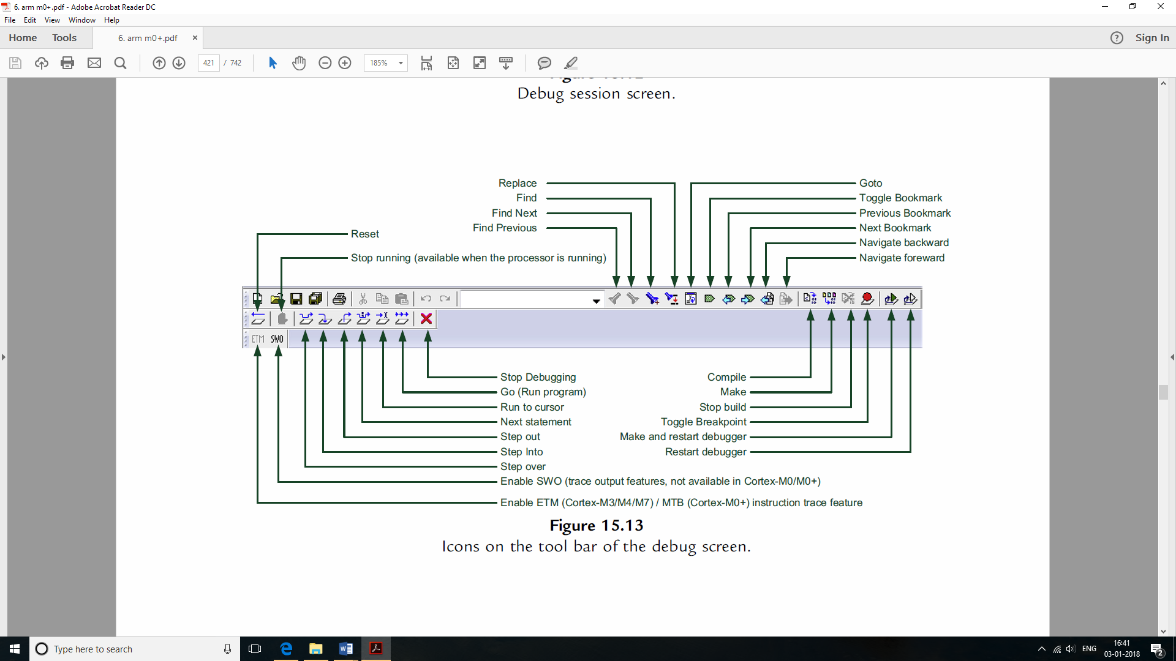

Figure 4.10 Icons on the tool bar of the debug screen.

By default, the register window is not enabled. To enable the register window, use the pull-down menu to select “View→Register.” You can insert or remove breakpoints by right clicking a line on the source window, and select toggle breakpoint. When the processor is halted, you can see the processor’s registers using the register window which can be accessed by pull down menu “View→Register.”

## 4.2 Toshiba Wireless starter kit

The TMPM369 Wireless starter kit is a development board by Toshiba to develop wireless applications using Wi-Fi, Bluetooth etc. The development board has a Cortex-M3 CPU and connectors as shown in the picture

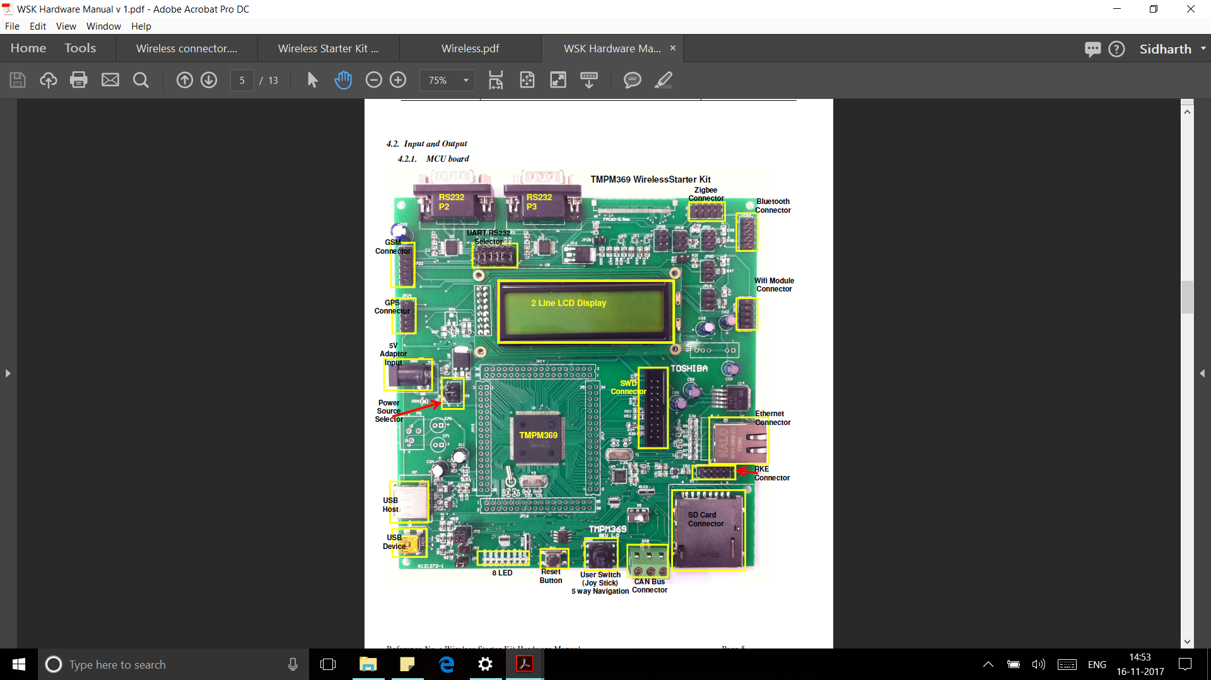

Figure 4.11 TMPM369 development board.

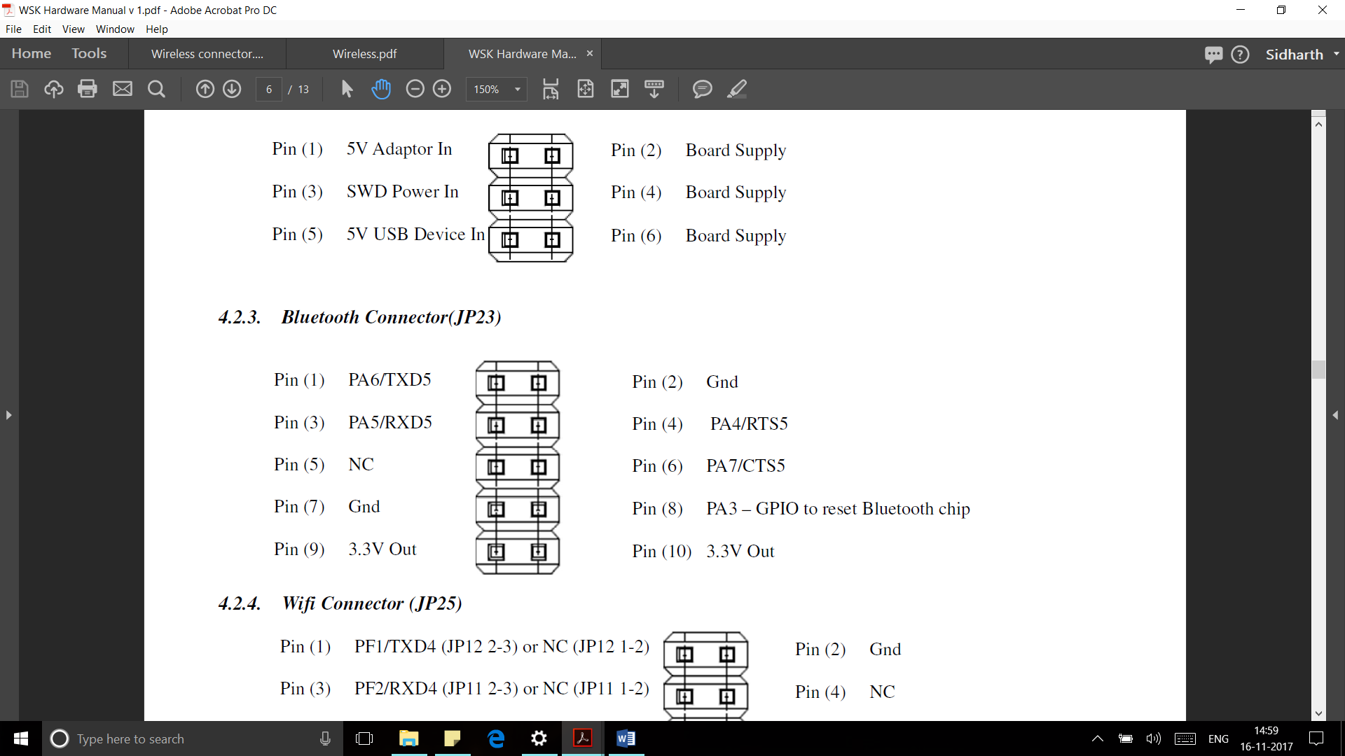

Figure 4.12 Bluetooth connector.

## 4.3 CMSIS DAP

CMSIS-DAP is the interface firmware for a Debug Unit that connects the Debug Port to USB. Debuggers, which execute on a host computer, connect via USB to the Debug Unit and to the Device that runs the application software. The Debug Unit connects via JTAG or SW to the target Device. ARM Cortex processors provide the CoreSight Debug and Trace Unit. CMSIS-DAP supports target devices that contain one or more Cortex processors.

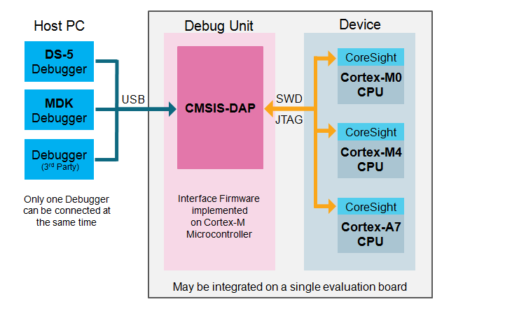

Figure 4.13 Debugging connection.

### 4.3.1 Pinout

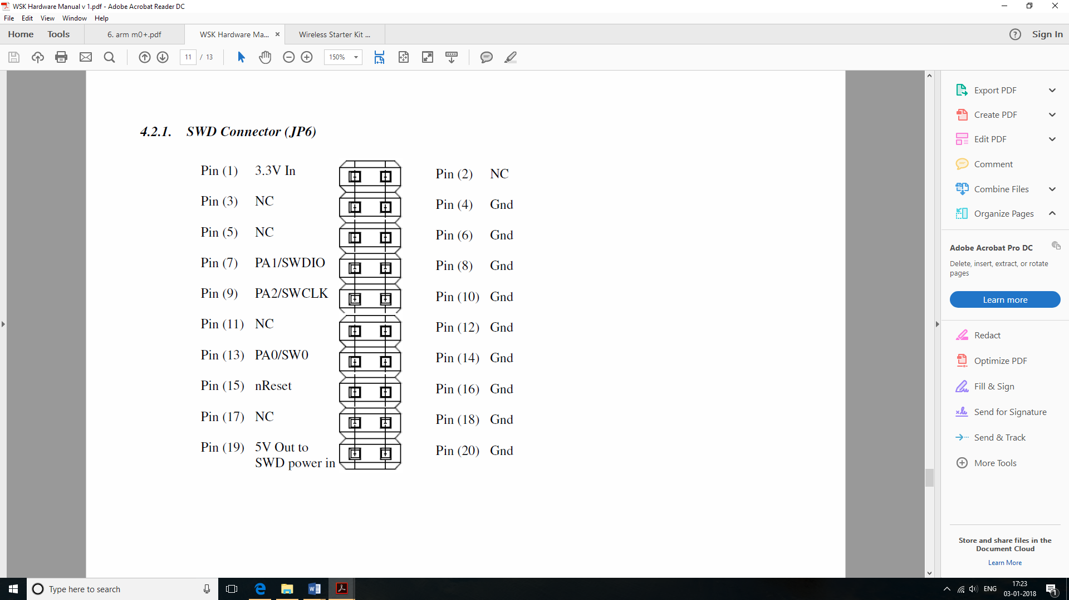

Figure 4.14 SWD pinout.

Table 4.3 SWD pinout

|  |  |  |  |
| --- | --- | --- | --- |
| Pin | signal | type | description |
| 1 | VTref | Input | This is the target reference voltage. It is used to check if the target has power, to create the logic-level reference for the input comparators and to control the output logic levels to the target. It is normally fed from Vdd of the target board |
| 4 | GND | GND | GND |
| 7 | SWDIO | I/O | Single bi-directional data pin. A pull-up resistor is required. ARM recommends 100 kOhms. |
| 9 | SWCLK | Output | Clock signal to target CPU. It is recommended that this pin is pulled to a defined state on the target board. Typically connected to TCK of the target CPU. |
| 15 | nRESET | I/O | Target CPU reset signal. Typically connected to the RESET pin of the target CPU, which is typically called “nRST”, “nRESET” or “RESET”. This signal is an active low signal. |

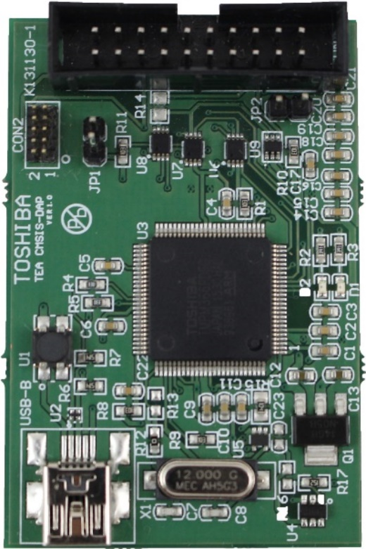

Figure 4.15 Toshiba CMSIS DAP Debugger.

## 4.4 STM Nucleo L053R8

The STM32 Nucleo board provides an affordable and flexible way for users to try out new ideas and build prototypes with any STM32 microcontroller line, choosing from the various combinations of performance, power consumption and features. The Arduino™ connectivity support and ST Morpho headers make it easy to expand the functionality of the STM32 Nucleo open development platform with a wide choice of specialized shields. The STM32 Nucleo board does not require any separate probe as it integrates the ST-LINK/V2-1 debugger and programmer. The STM32 Nucleo board comes with the STM32 comprehensive software HAL library together with various packaged software examples, as well as direct access to mbed online resources.



Figure 4.16 STM32 Nucleo-64 board.

The ST-LINK/V2-1 programming and debugging tool is integrated in the STM32 Nucleo board. The ST-LINK/V2-1 makes the STM32 Nucleo boards mbed enabled. The embedded ST-LINK/V2-1 supports only SWD for STM32 devices.

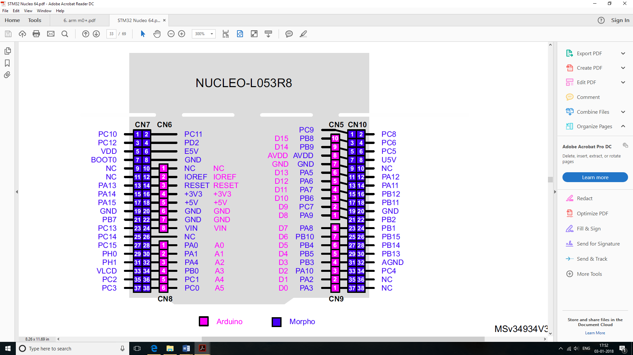

Figure 4.17 STM32 Nucleo-L053R8 connectors.

## 4.5 PuTTY

PuTTY is a free and open-source terminal emulator, serial console and network file transfer application. It supports several network protocols, including SCP, SSH, Telnet, rlogin, and raw socket connection. It can also connect to a serial port. The name "PuTTY" has no definitive meaning.

PuTTY was originally written for Microsoft Windows, but it has been ported to various other operating systems. Official ports are available for some Unix-like platforms, with work-in-progress ports to Classic Mac OS and macOS, and unofficial ports have been contributed to platforms such as Symbian, Windows Mobile and Windows Phone.

PuTTY consists of several components:

* PuTTY: the Telnet, rlogin, and SSH client itself, which can also connect to a serial port
* PSCP: an SCP client, i.e. command-line secure file copy
* PSFTP: an SFTP client, i.e. general file transfer sessions much like FTP
* PuTTYtel: a Telnet-only client
* Plink: a command-line interface to the PuTTY back ends
* Pageant: an SSH authentication agent for PuTTY, PSCP and Plink
* PuTTYgen: an RSA, DSA, ECDSA and EdDSA key generation utility
* pterm: a standalone terminal emulator

Here we use PuTTY for serial communication between the microcontroller and PC.

### 4.5.1 Setting up a serial terminal

Select the “Serial” option under “Connection type:” as shown in Figure 4.18. Specify the COM port under “Seial line” and set the baud rate under “Speed”. Open “Serial” Tab under “Connection” in “Category:” sidebar, a window will appear as shown in Figure 4.19. Make settings accordingly. Click Open to open serial terminal as shown in Figure 4.20.

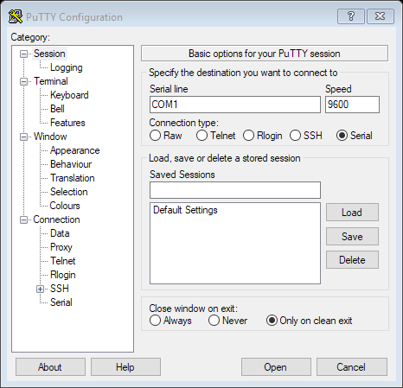

Figure 4.18 PuTTY Configuration window

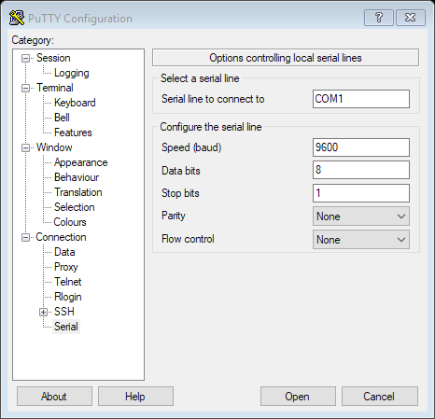

Figure 4.19 Serial options window

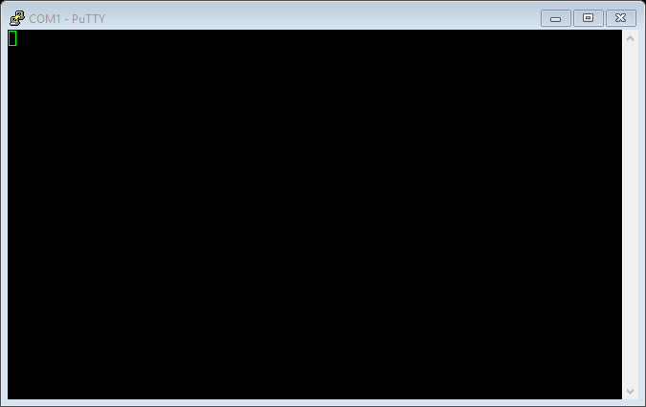

Figure 4.20 Serial Terminal

## 4.6 STM32 CubeMX

STM32CubeMX is a part of STMicroelectronics STMCube original initiative to make developers lives easier by reducing development effort, time and cost. STM32 Cube covers the whole STM32 portfolio.

STM32CubeMX is a graphical software configuration tool that allows the generation of C initialization code using graphical wizards.

It also embeds comprehensive STM32Cube MCU Packages, delivered per STM32 microcontroller Series. These packages include the STM32Cube HAL (an STM32 abstraction layer embedded software ensuring maximized portability across STM32 portfolio), the STM32Cube LL (low-layer APIs, a fast, light-weight, expert-oriented layer), plus a consistent set of middleware components such as RTOS, USB, TCP/IP and graphics. All the embedded software utilities are delivered with a full set of examples.

**Key Features:**

* Intuitive STM32 microcontroller selection.
* C Code project generation covering STM32 microcontroller initialization compliant with IAR, Keil and GCC compilers.
* Available as standalone software running on Windows, Linux and macOS operating systems, or through Eclipse plug-in.
* Microcontroller graphical configuration:
  + Pinout with automatic conflict resolution.
  + Clock tree with dynamic validation of configuration.
  + Peripherals and middleware functional modes and initialization with dynamic validation of parameter constraints.
  + Power sequence with estimate of consumption results.

STM32CubeMX is a graphical tool that allows a very easy configuration of STM32 microcontrollers and the generation of the corresponding initialization C code through a step-by-step process.

### 4.6.1 Demo of Project Making and Initialization Process:

**Step 1:** Open the STM32CubeMX software and click on New Project.

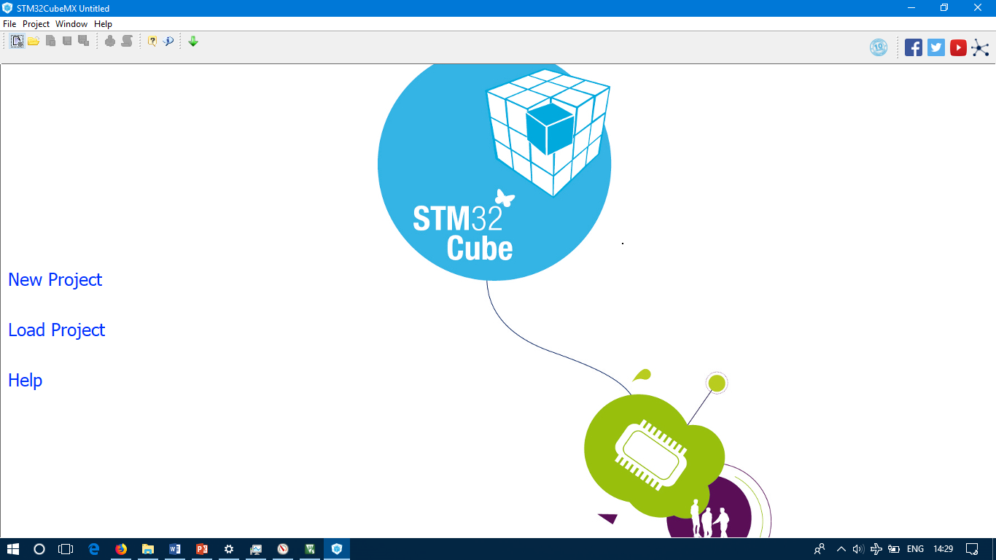

Figure 4.21

**Step 2:** Search the required microcontroller either by name or by configuring other choices. 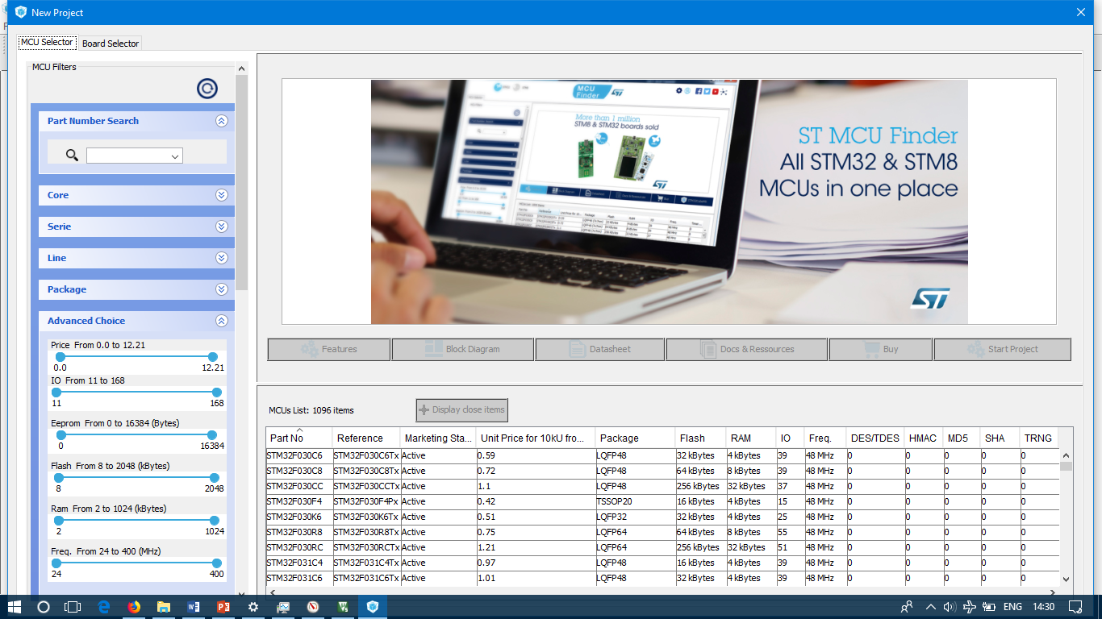

Figure 4.22

**Step 3:** Select the required microcontroller and click on Start Project.

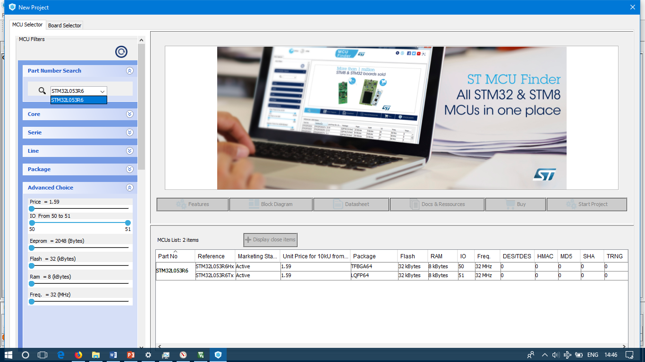

Figure 4.23

**Step 5:** Using the graphical tool, configure the required features.

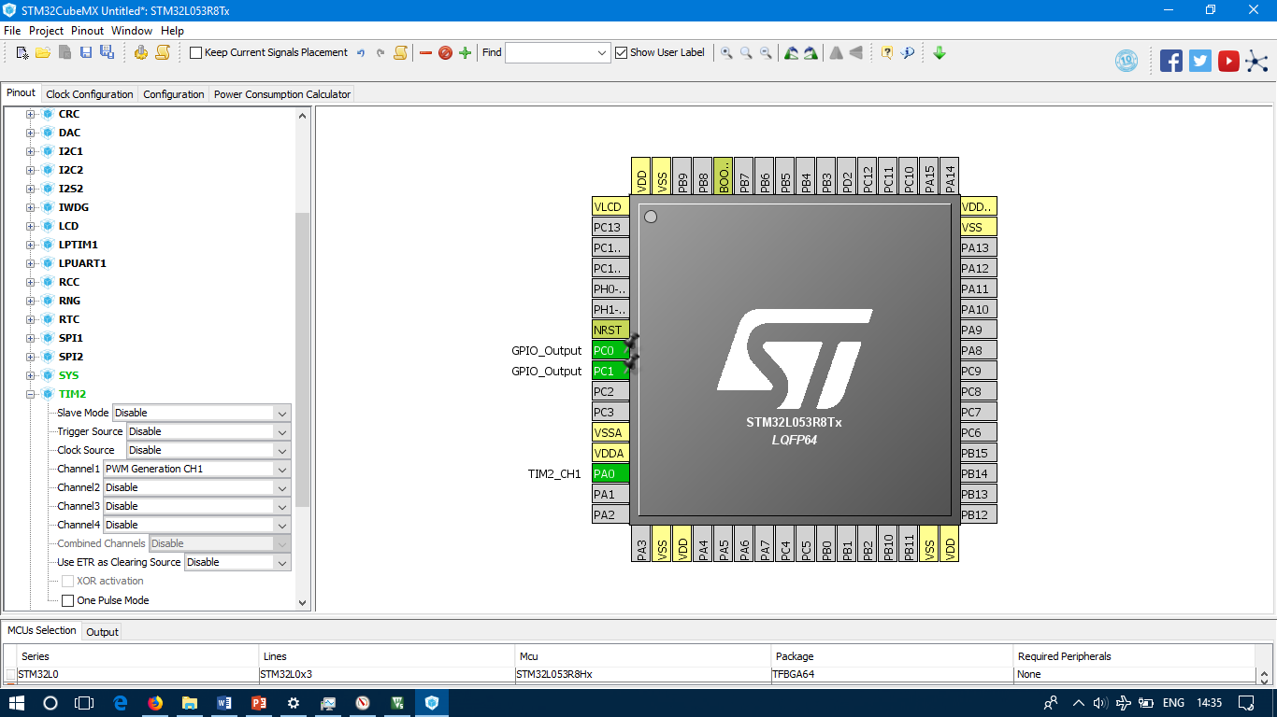

Figure 4.24

**Step 6:** Click on Clock Configuration tab and configure the clock as necessary.

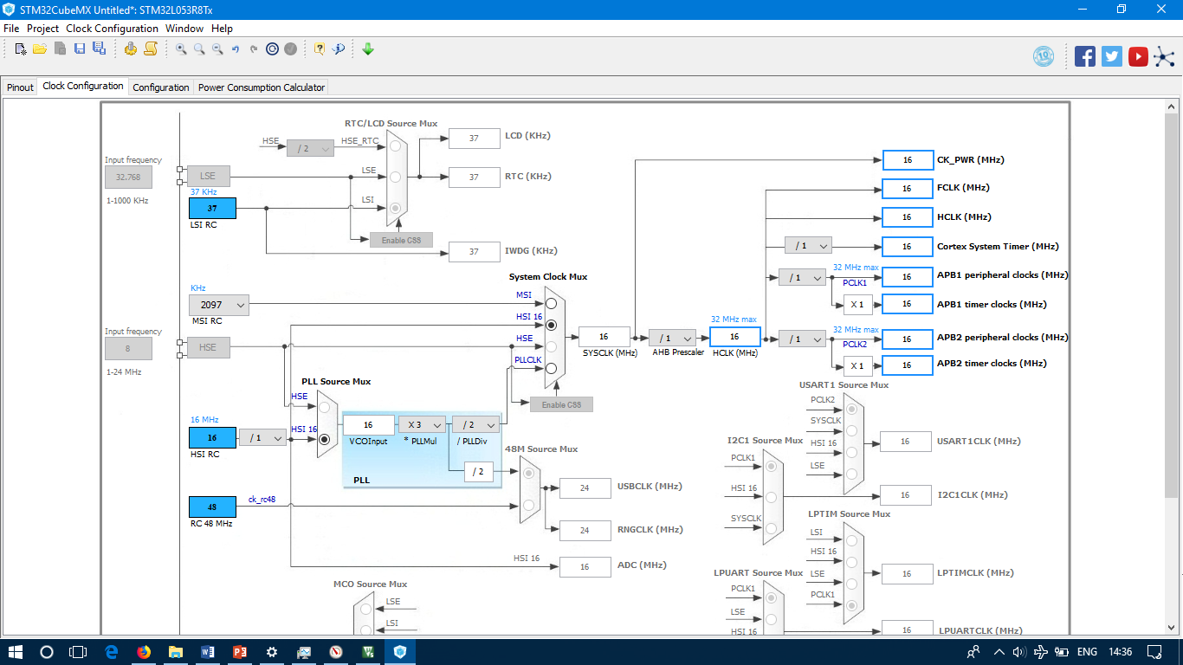

Figure 4.25

**Step 7:** Click on the Configuration tab and configure additional settings if required.

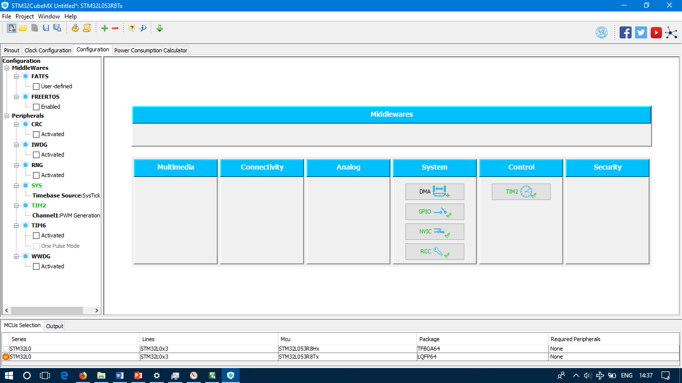

Figure 4.26

**Step 8:** After configuration, click on Project > Settings.

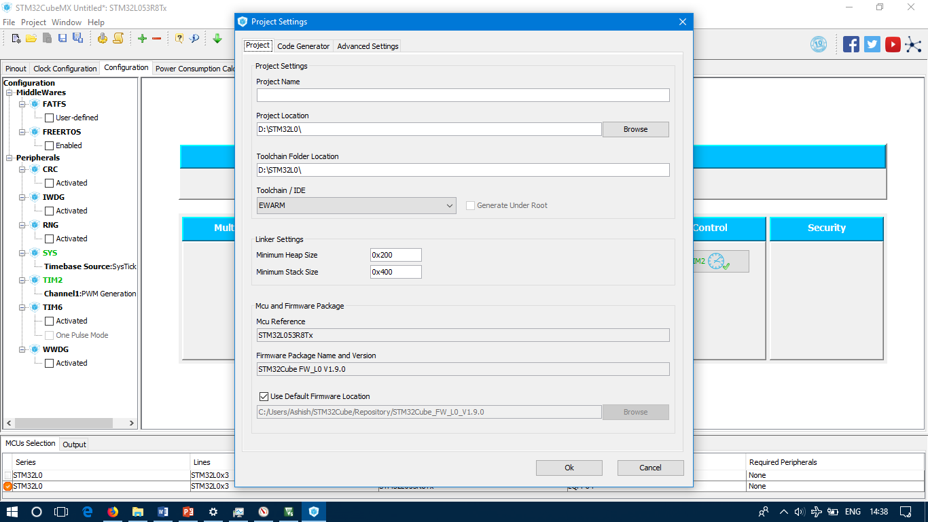

Figure 4.27

**Step 9:** Enter Project Name, Location of the project and select the toolchain/IDE to MDK-ARM V5 and click on OK.

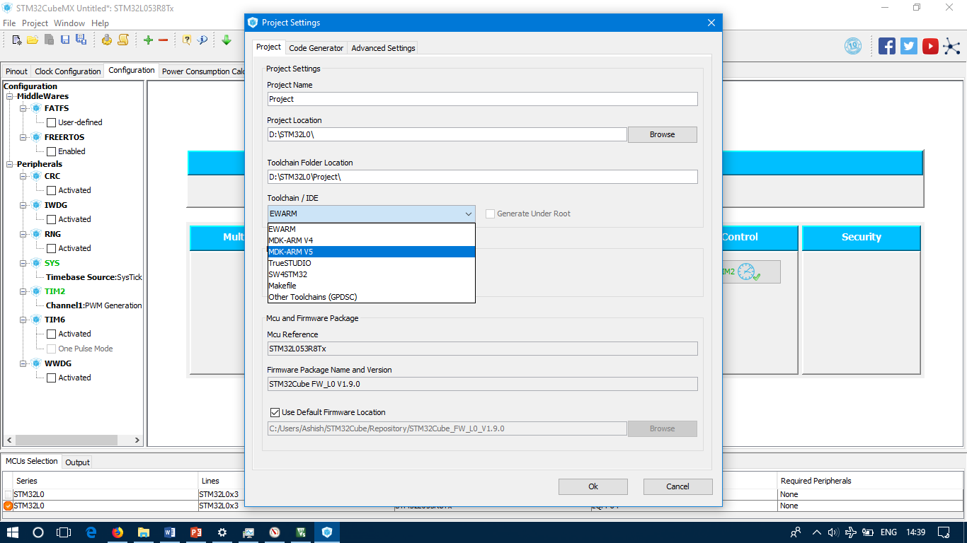

Figure 4.28

**Step 10:** Click Project > Generate Code.

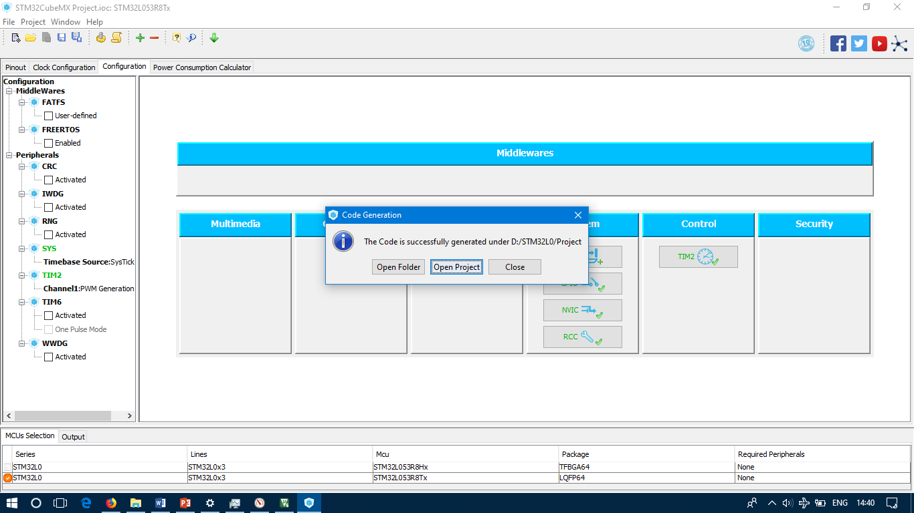

Figure 4.29

**Step 11:** Click on Open Project and the project should open in the IDE.

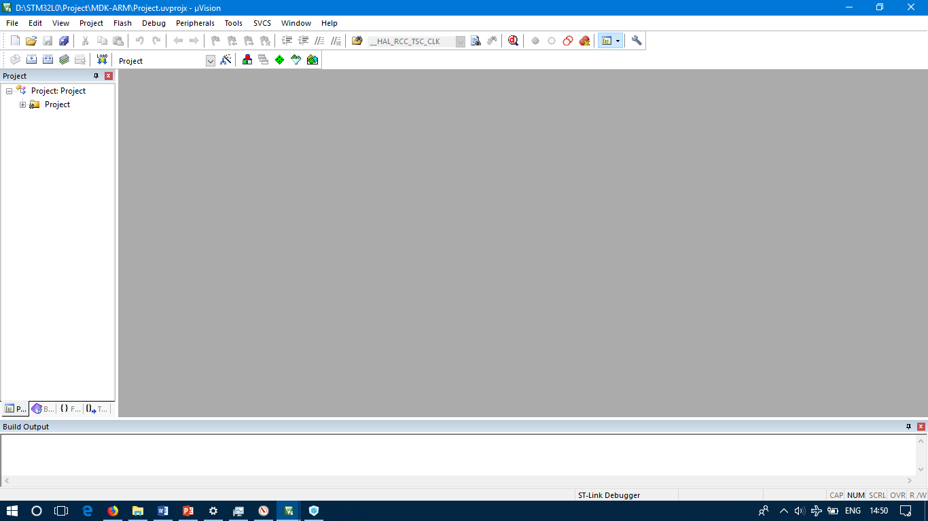

Figure 4.30

## 4.7 µVISION ide

The µVision IDE combines project management, run-time environment, build facilities, source code editing, and program debugging in a simple powerful environment. µVision is easy-to-use and accelerated your embedded software development. µVision supports multiple screens and allows you to create individual window layouts anywhere on the visual surface.

The µVision debugger provides a single environment in which you may test, verify, and optimize your application code. The debugger includes traditional features like simple and complex breakpoints, watch windows, and execution control ad provides full visibility to device peripherals.

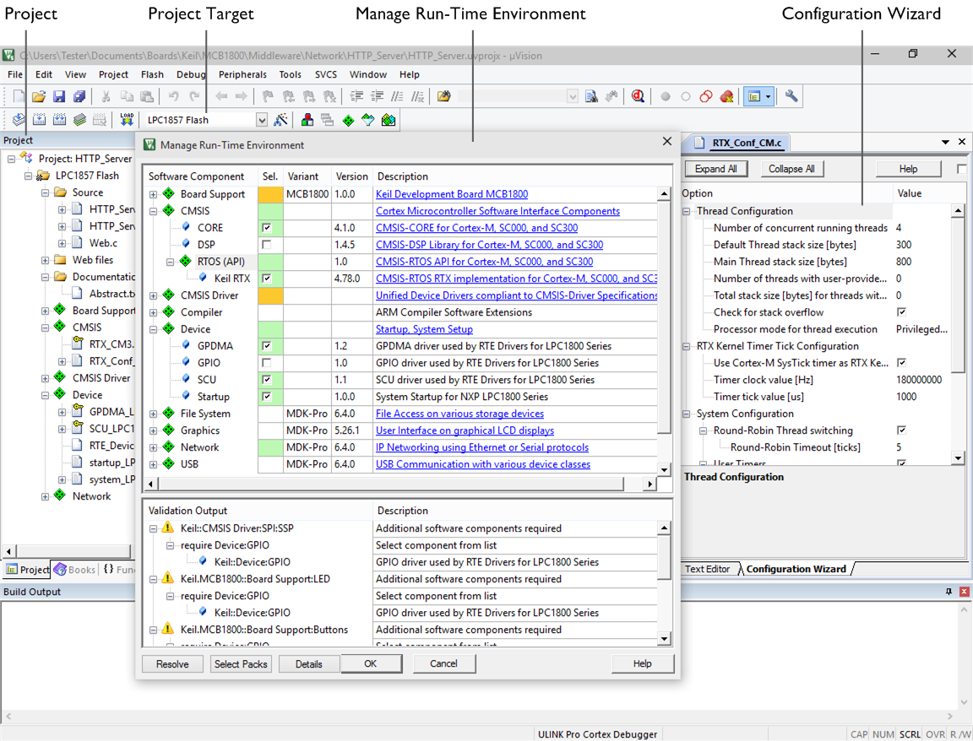

Figure 4.31

### 4.7.1 µVision Project Manager and Run-Time Environment

With the µVision Project Manager and Run-Time Environment you create software application using pre-build software components and device support from Software Packs. The software components contain libraries, source modules, configuration files, source code templates, and documentation. Software components can be generic to support a wide range of devices and applications.

* The **Project** window shows application source files and selected software components. Below the components you will find corresponding library and configuration files.
* **Projects** support multiple **targets**. They ease configuration management and may be used to generate debug and release builds or adoptions for different hardware platforms.
* The **Manage Run-Time Environment** window shows all software components that are compatible with the selected device. Inter-dependencies of software components are clearly identified with validation messages.
* The **Configuration Wizard** is an integrated editor utility for generating GUI-like configuration controls in assembler, C/C++, or initialization files.

### 4.7.2 µVision Editor

The integrated µVision Editor includes all standard features of a modern source code editor and is also available during debugging. Color syntax highlighting, text indentation, and source outlining are optimized for C/C++.

* The **Functions** window gives fast access to the functions in each C/C++ source code module.
* The **Code Completion** list and **Function Parameter** information helps you to keep track of symbols, functions, and parameters.
* **Dynamic Syntax Checking** validates the program syntax while you are typing and provides real-time alerts to potential code violations before compilation.

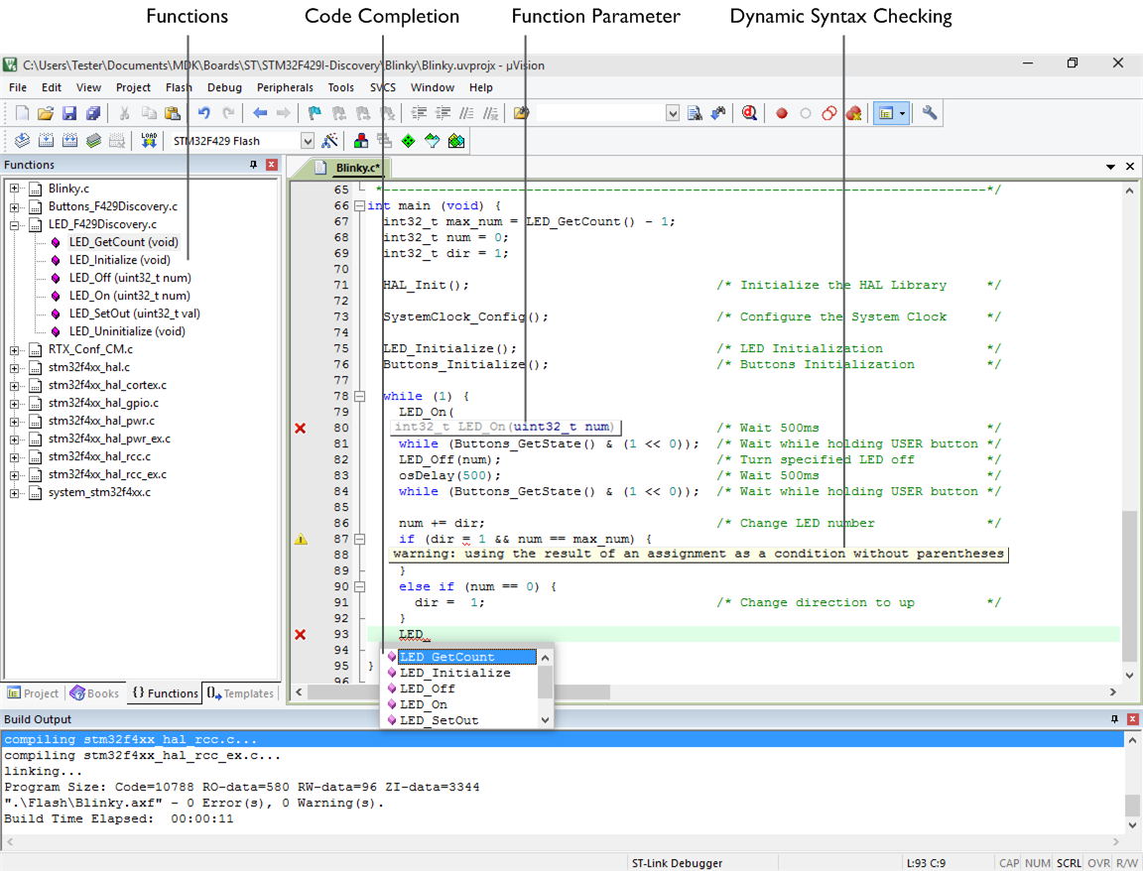

Figure 4.32

1. **Bluetooth**

# Bluetooth

Bluetooth is a wireless technology standard for exchanging data over short distances (using short-wavelength UHF radio waves in the ISM band from 2.4 to 2.485 GHz) from fixed and mobile devices, and building personal area networks (PANs). Invented by telecom vendor Ericsson in 1994, it was originally conceived as a wireless alternative to RS-232 data cables.



Fig 5.1 Bluetooth Logo

Bluetooth is managed by the Bluetooth Special Interest Group (SIG), which has more than 30,000-member companies in the areas of telecommunication, computing, networking, and consumer electronics. The IEEE standardized Bluetooth as IEEE 802.15.1, but no longer maintains the standard. The Bluetooth SIG oversees development of the specification, manages the qualification program, and protects the trademarks. A manufacturer must meet Bluetooth SIG standards to market it as a Bluetooth device. A network of patents applies to the technology, which are licensed to individual qualifying devices.

Bluetooth operates at frequencies between 2402 and 2480 MHz, or 2400 and 2483.5 MHz. Bluetooth uses a radio technology called frequency-hopping spread spectrum.

Bluetooth is a standard wire-replacement communications protocol primarily designed for low-power consumption, with a short range based on low-cost transceiver microchips in each device. Because the devices use a radio (broadcast) communications system, they do not have to be in visual line of sight of each other.

Bluetooth exists in many products, such as telephones, speakers, tablets, media players, robotics systems, handheld, laptops, console gaming equipment as well as some high definition headsets, modems, and watches. The technology is useful when transferring information between two or more devices that are near each other in low-bandwidth situations. Bluetooth is commonly used to transfer sound data with telephones (i.e., with a Bluetooth headset) or byte data with hand-held computers (transferring files).

Bluetooth protocols simplify the discovery and setup of services between devices. Bluetooth devices can advertise all of the services they provide. This makes using services easier, because more of the security, network address and permission configuration can be automated than with many other network types. To use Bluetooth wireless technology, a device must be able to interpret certain Bluetooth profiles, which are definitions of possible applications and specify general behaviours that Bluetooth-enabled devices use to communicate with other Bluetooth devices. These profiles include settings to parameterize and to control the communication from the start. Adherence to profiles saves the time for transmitting the parameters anew before the bi-directional link becomes effective. There are a wide range of Bluetooth profiles that describe many different types of applications or use cases for devices.

## 5.1 Serial Port Profile (SPP)

This profile is based on ETSI 07.10 and the RFCOMM protocol. It emulates a serial cable to provide a simple substitute for existing RS-232, including the familiar control signals. It is the basis for DUN, FAX, HSP and AVRCP. SPP maximum payload capacity is 128 bytes.

Serial Port Profile defines how to set up virtual serial ports and connect two Bluetooth enabled devices.

## 5.2 Bluetooth Protocols

The wireless data exchange standard Bluetooth uses a variety of protocols. Core protocols are defined by the trade organization Bluetooth SIG. Add protocols have been adopted from other standards bodies.

### 5.3 Host controller interface (HCI)

The pseudo-protocol referring to any standardized communication between the host stack (e.g., a PC or mobile phone OS) and the controller (the Bluetooth IC). An HCI decouples the host from the controller, allowing either to be swapped without affecting the other. Bluetooth defines several HCI standards, each for a different hardware interface to transfer the same commands, events, and data packets. The most commonly used are USB (in PCs) and UART (in mobile phones and PDAs).

It must expose enough functionality to allow the host: to discover, add, and manage devices on the piconet; to configure controller properties; to set up, manage, and release logical transports and links; and to write directly to the baseband's buffer for SCO and eSCO streaming.

In simple Bluetooth devices (e.g., headsets), the host stack and controller can be implemented on the same microprocessor. In this case an HCI serves no purpose, and often implemented only as an internal software interface.

1. **Toshiba TC35661**

# Toshiba TC35661

The TC35661 series are highly integrated RFCMOS Bluetooth devices which support Bluetooth Classic (3.0+EDR) and Bluetooth Low Energy (LE) 4.0 and 4.2 standards. TC35661 supports the standard Bluetooth HCI interface and offers integration of stack and selected BT profiles on-chip.  Through its WIFI coexistence interface it supports the BT3.0-HS function.  The devices realise an easy way to integrate Bluetooth for various industrial, medical and automotive applications.  Toshiba has tested the Bluetooth interoperability extensively.  All Toshiba Bluetooth devices and software are Bluetooth Qualification Expert (BQE) qualified.

## 6.1 Key Benefits

* Dual Mode core for classic and Bluetooth 4.0 and 4.2 standards
* BQE qualified hardware and software for easy Bluetooth EPL
* Flexible system architectures through:
  + HCI model
  + Embedded profile model
  + Standalone model
* Embedded on-chip Bluetooth stack and selected profiles for easy Bluetooth system design
* Standalone operation for small applications is feasible without a host MCU
* Ultra-low bill of materials due to very few external components
* Multiple programmable IO options
* On-chip voltage controller and low power modes
* Consumer and automotive qualification (AEC-Q100)

## 6.2 Features

* Bluetooth® Core Spec 3.0, 4.0 and 4.2, EDR and LE support
* TC35661–0XX: HCI type
* TC35661–XXX: embedded profile type
* BT Class 2 support
* RX Sensitivity –91dBm (typ.)
* Baseband with ARM® CPU - 13 to 52 MHz
* On–chip ROM, RAM, including Patch–RAM
* On–chip balun, antenna switch, LNA, LDO
* Interfaces: UART, SPI, USB2.0(FS), I2C, I2S/PCM, GPIO
* IEEE802.15.2. 2/3/4 coexistence interface
* Data transfer up to 2 Mbps (DH5 packets) net
* Package: 64ball BGA (ROM version), 0.5/0.8mm pitch, 1.2/1.4mm height
* Operational voltage: 1.8V or 3.3V (typ.)
* Low power sleep mode 30uA (max)
* Operation mode well below 30mA (depends on packet-type and selected operational mode)
* AEC-Q100 automotive qualification on selected devices (0.8mm pitch)

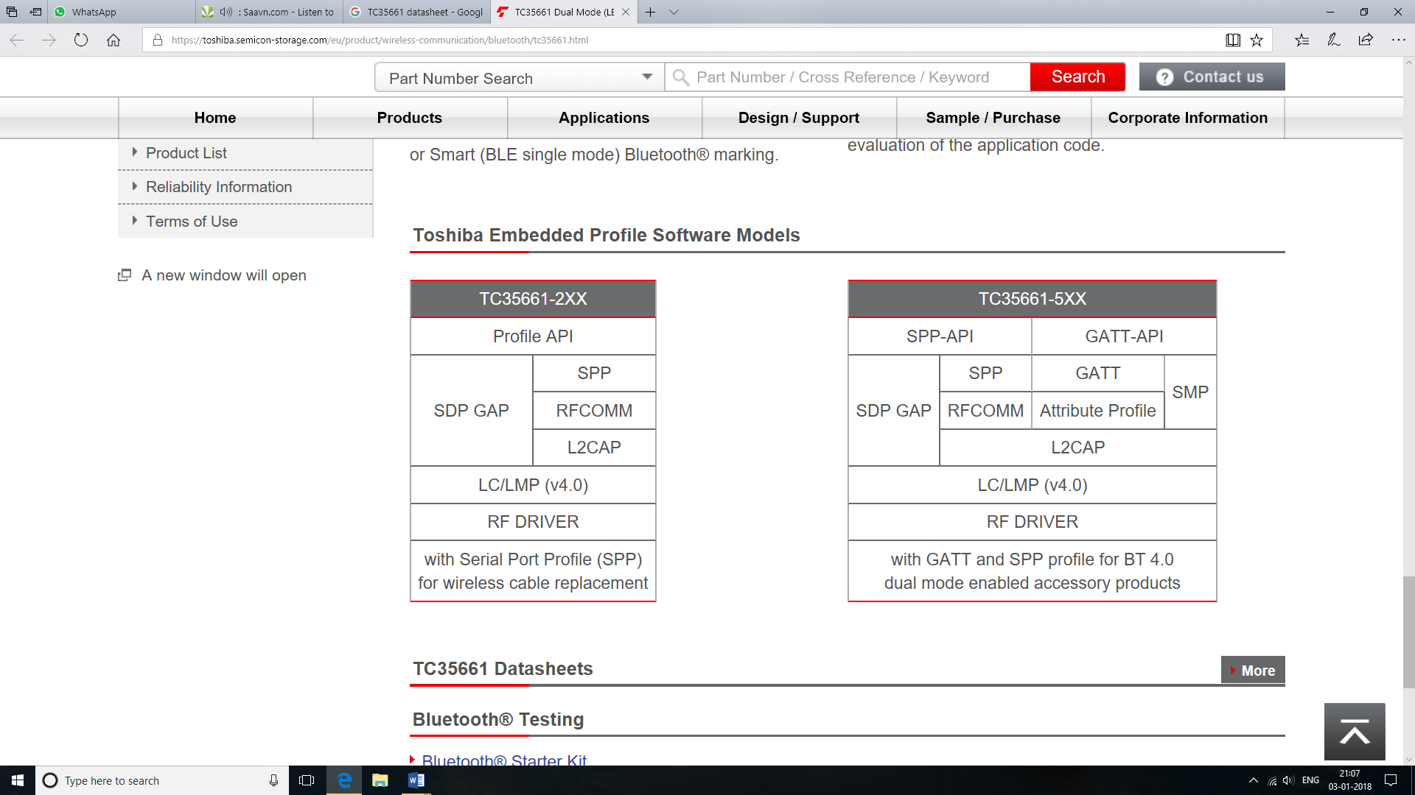

Figure 6.1 Toshiba Embedded Profile Software Models

## TC35661SBG-503 Bluetooth® IC

Table 6.1 Description

|  |  |
| --- | --- |
| Feature | BR+LE dual / Small BGA Package |
| Automotive Support | N/A |
| Bluetooth Category | Bluetooth® dual-mode |
| Bluetooth Core spec. | 4.2 |
| Embedded Profiles | GATT / SMP / SPP |
| Interfacing | I2C / SPI / UART |
| User RAM Size (KB) | N/A |
| User Flash Size (KB) | N/A |
| Function | ARM® ARM7TDMI-S™ / RF analog circuitry / low power mode |
| RoHS Compatible Product(s) (#) | Available |
| Assembly bases | Japan / Taiwan |
| Status | Under mass production |

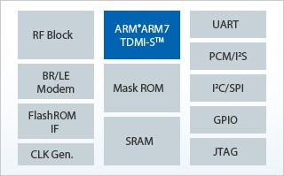 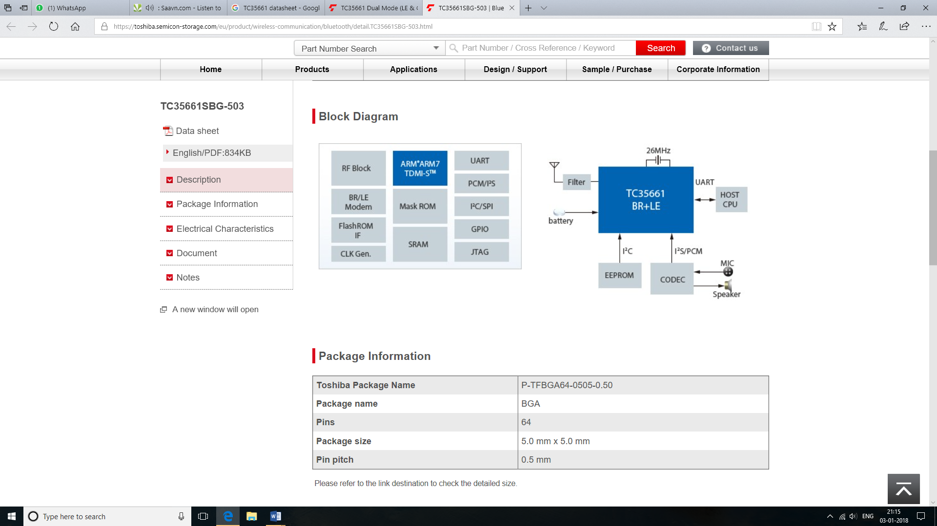

Figure 6.2 TC35661-503 Block Diagram

Table 6.2 Electrical Characteristics

|  |  |  |  |  |
| --- | --- | --- | --- | --- |
| Characteristics | Symbol | Condition | Value | Unit |
| Operating Temperature (Max) | Topr | - | 85 (*1) | ℃ |
| Operating Temperature (Min) | Topr | - | -20 or -40 (*1) | ℃ |
| Power supply voltage (Max) | - | - | 3.6 (*2) | V |
| Power supply voltage (Min) | - | - | 1.7 (*2) | V |
| Current Consumption in RX Active mode (peak) | IRX | (3.3V) | 63 | mA |
| Current Consumption in TX Active mode (peak) | ITX | (3.3V) | 63 | mA |
| Current Consumption in Sleep mode | ISleep | - | 30 | μA |
| Transmit Power(Max) | PTrans | - | 2 | dBm |
| Receiver Sensitivity | - | - | -91 | dBm |

## 6.3 UART Interface:

A universal asynchronous receiver-transmitter (UART) is a computer hardware device for asynchronous serial communication in which the data format and transmission speeds are configurable. The electric signalling levels and methods are handled by a driver circuit external to the UART. A UART is usually an individual (or part of an) integrated circuit (IC) used for serial communications over a computer or peripheral device serial port. UARTs are now commonly included in microcontrollers. A related device, the universal synchronous and asynchronous receiver-transmitter (USART) also supports synchronous operation.

1. **Modules Implemented**

# Modules Implemented

## 7.1 Porting code from TMPM 369 to Nucleo board

* This task first required studying of TC35661-503 ROM specifications and hardware specifications to gain knowledge of the ICs working and connections. The IC communicates with controller using UART and works on 3.3V. It works on Bluetooth classic profile.
* The 2nd step was to debug the existing code to understand code flow and identify the code which was specific to TMPM 369 board. This code was available on IAR workbench.
* Once this was done code was changed to run on STM32 board which was done with help of CubeMX on Keil IDE.

## 7.2 Writing AT commands for module

* The task required to study what all feature the competing products were giving the modules studied were SMBT-1T02 and HC-05
* To make module communicate with other devices another serial communication line was implemented on the STM32 controller.
* The third step was to write code that could differentiate data from AT commands and process corresponding actions when AT command is encountered.

## 7.3 Future goals of project

* Implementing a comprehensive set of AT commands
* Replacing prototype controller with cheaper alternatives

1. **Applications**

# Applications

## Example 1: Light Switch Controller

Background Consider a small microcontroller controlling a single light switch. The microcontroller’s serial port is connected to the Module and a digital output line drives a relay which controls a light. The remote host sends the text “ON” to switch on the relay and “OFF” to switch it off.

## Example 2: Remote Data Logger

A data logger on a remote site gathers data which is then transferred to a central site via a Bluetooth enabled phone. Assume that the remote site is accessed via the telephone and the PC connected to the modem logs the data to a file, so all the data logger has to do is open a connection and then send textual data corresponding to the gathered data.

## Example 3: Wearables

A Bluetooth module can be used to pair a fitness device with mobile phone. The Bluetooth module will transmit data from sensors like Heart rate sensor, UV sensor, temperature sensor and steps sensor to mobile phone via Bluetooth. The mobile phone can display this data to the user in an app.

1. **References**

# References

* <https://toshiba.semicon-storage.com/eu/product/wireless-communication/bluetooth/tc35661.html>
* TMPM369 Wireless starter kit documentation
* ARM Cortex M0+ by Joseph Yiu
* Mastering STM32 by Carmine Noviello
* STM Nucleo64 User manual
* STM32 L0xx User manual
* <https://en.wikipedia.org/wiki/Bluetooth>
* <http://docs-europe.electrocomponents.com/webdocs/08d8/0900766b808d8ac5.pdf>
* SMBT 1T-02 documentation
* HC-05 documentation
* <https://learn.sparkfun.com/tutorials/terminal-basics>
* <https://www.iar.com/iar-embedded-workbench/>
* <https://en.wikipedia.org/wiki/PuTTY>